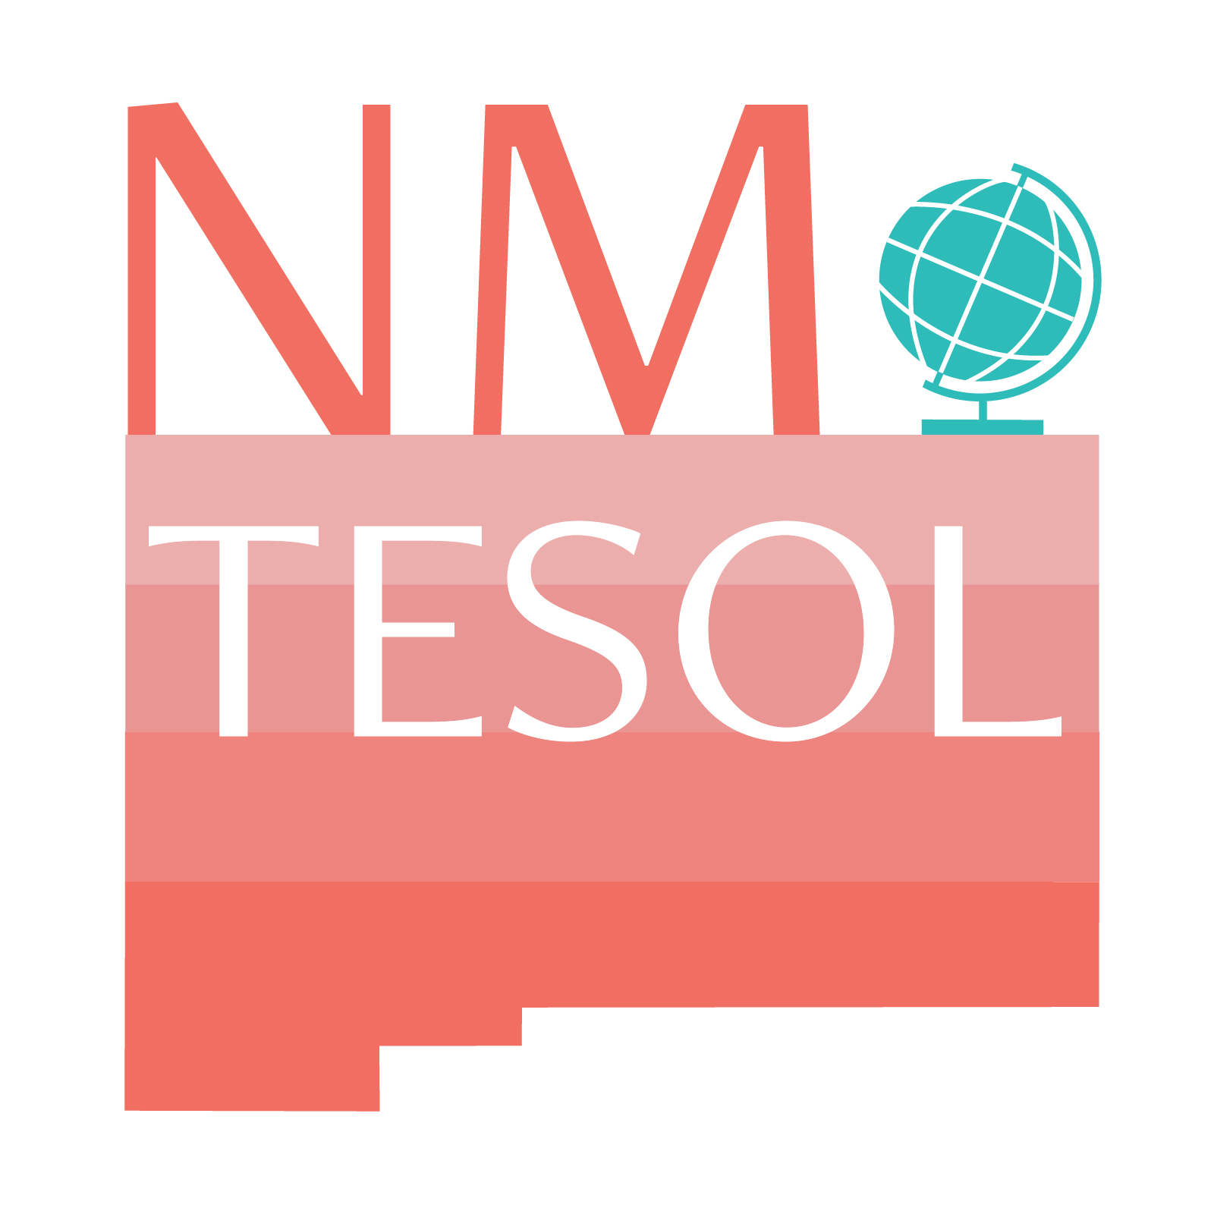 | New Decade!  New Ideas!  NM TESOL Spring Workshop  Friday, March 6, 2020  Central New Mexico Community College  Montoya Campus  Albuquerque, NM

Session Proposal
New Mexico Teachers of English to Speakers of Other Languages (NM TESOL) is looking for high-quality proposals focused on topics related to best practices in teaching ESL. Share your fresh ideas for what you do with other New Mexico professionals! Please complete this application and email it to nmtesol@gmail.com by February 7, 2020.

Selections will be made and proposers will be notified by the middle of February. The selection committee values interactive sessions that include active learning strategies such as Think, Pair, Share; hands-on practice; Gallery Walk, etc., so we are looking for sessions that go beyond “presentation” and engage the attendees (see rubric evaluation criteria at the end of this document.)

- Contact Information
Please write presenter name(s) exactly how you would like them to appear on the printed program, including any credentials (Ph.D., etc.)
Presenter #1 Full Name: Click here to enter text.
Presenter #1 Institution/School/Department: Click here to enter text.
Presenter #1 Email Address: Click here to enter text.

Presenter #2 Full Name: Click here to enter text.
Presenter #2 Institution/School/Department: Click here to enter text.
Presenter #2 Email Address: Click here to enter text.

Presenter #3 Full Name: Click here to enter text.
Presenter #3 Institution/School/Department: Click here to enter text.
Presenter #3 Email Address: Click here to enter text.
- Format
Select the format that best describes your proposal. Select just one.
☐ 90-minute Presentation: A dynamic, multimedia, or interactive presentation designed to provide session attendees with information, insight, and possibly hands-on practice.

☐ 60-minute Presentation: A dynamic, multimedia, or interactive presentation designed to provide session attendees with information, insight, and possibly hands-on practice.
☐ 6 minute and 40 seconds PechaKucha Presentation: Join six other teachers in this rapid fire 20-slide PowerPoint presentation where you comment for 20 seconds on each slide. You can share a successful icebreaker, activity, or teaching strategy. Read more about this type of presentation which originated in Japan here.

- Proposed Session Title: (please make sure your title accurately reflects the topic of your session) Click here to enter text.

- Description of Session (to be included in the Conference Program) 150 words maximum: Please provide a detailed description of the format, focus, content, intended audience and intended outcomes of your proposed presentation. Also, mention whether you wish attendees to bring a mobile device to your session.

Click here to enter text.

- AV Requirements
Each session location will be equipped with Internet access (either wired or wireless), a projector and screen, a document camera, dry erase markers, and amplified sound for A/V equipment. Presenters should plan to bring their personal laptops or other electronic devices to connect to facility equipment. Conference attendees will be asked to bring their own mobile online technology, such as laptops, tablets, smart phones, etc.
If you would like additional technology to be available for your use, please describe it here, and conference organizers will make an effort to provide it.
Click here to enter text.

2020 NM TESOL Workshop

Session Proposal Selection Criteria

For use by the selection committee.
The NM TESOL Board members will be evaluating all session proposals according to the criteria outlined in this rubric.

 | Criteria | Rate 0-5
Focus and content | The session content directly addresses Teaching English Language Learners, and meets basic academic standards in the field.
Focus and content | The session content has been identified as needed and in demand by teachers.
Focus and content | There is broad audience appeal.
Session plan | The session plan is clearly described. Board members can picture how the session will proceed.
Session plan | The session plan encourages active learning by the participants; it includes interactive components, such as small group discussion, gallery walk, and/or hands-on activity.
Session plan | The session format selected is appropriate in scope and focus for the subject matter and time allotted.
Total

